
Mutual Fund Analytics (Bluestock Fintech)
Capstone Project Report

Submitted To:
Bluestock Fintech
Submitted By
Swapnil Singh
Project Domain
Data analyst | Finance Analyst
Tools & Technologies Used
- Microsoft Power BI
- Microsoft Excel
- Python (Jupyter Notebook)
- PostgreSQL
- Pandas
- NumPy
- Power Query
- DAX (Data Analysis Expressions)
Purpose of Each Tool
Microsoft Excel
- Performed initial exploration of the datasets.
- Verified data structure and column consistency before processing.
Python (Jupyter Notebook)
- Cleaned and preprocessed raw datasets.
- Handled missing values and duplicate records.
- Standardized column names and formats.
- Prepared clean datasets using Pandas and NumPy for further analysis.
PostgreSQL
- Imported the cleaned datasets into a relational database.
- Managed structured data using SQL.
- Connected PostgreSQL to Power BI for efficient data retrieval and reporting.
Power Query
- Connected Power BI to the PostgreSQL database.
- Performed additional transformations and data shaping.
- Changed data types, renamed columns, and prepared tables for analysis.
DAX (Data Analysis Expressions)
- Developed KPIs and calculated measures.
- Created dynamic titles and business calculations.
- Implemented analytical measures for dashboard interactivity.
Microsoft Power BI
- Designed the data model and relationships.
- Built four interactive dashboards.
- Created professional visualizations, slicers, KPIs, and navigation.
- Delivered an interactive business intelligence solution for mutual fund analysis

Certificate
I hereby declare that this project titled "Mutual Fund Analytics Dashboard Using Power BI" is my original work completed as part of the Bluestock Capstone Project. The work presented in this report has been developed using the provided datasets and appropriate analytical techniques. All analyses, dashboard designs, DAX calculations, and visualizations were created by me for educational and portfolio purposes.
Submitted by:
Swapnil Singh
Acknowledgement
I would like to express my sincere gratitude to Bluestock Fintech for providing me with the opportunity to work on this Mutual Fund Analytics Dashboard project.
I am thankful to the mentors and the Bluestock team for their valuable guidance, project resources, and continuous support throughout the capstone program.
This project enabled me to strengthen my practical knowledge of Microsoft Power BI, data transformation using Power Query, DAX calculations, data modeling, and dashboard development. It also helped me gain valuable experience in solving real-world business problems through data analytics and visualization.
Finally, I would like to thank everyone who directly or indirectly contributed to the successful completion of this project.

Executive Summary
The Mutual Fund Analytics Dashboard is a Business Intelligence project developed as part of the Bluestock Fintech Capstone Program to transform raw mutual fund and investor data into meaningful, interactive, and actionable insights. The primary objective of this project is to provide investors, financial analysts, and fund managers with a comprehensive analytical platform for monitoring mutual fund performance, understanding investor behavior, and evaluating SIP (Systematic Investment Plan) market trends.
The project follows a complete end-to-end data analytics workflow. Initially, raw datasets containing information on mutual fund schemes, fund houses, investor transactions, category inflows, NAV history, and SIP trends were collected. These datasets were cleaned and preprocessed using Python (Jupyter Notebook) with the help of the Pandas and NumPy libraries. Data quality issues such as missing values, duplicate records, inconsistent data formats, and unnecessary columns were identified and addressed to ensure the reliability and accuracy of the data.
After preprocessing, the cleaned datasets were imported into a PostgreSQL database, where they were organized into structured relational tables. PostgreSQL served as the centralized data source, enabling efficient data management and seamless connectivity with Microsoft Power BI.
The PostgreSQL database was then connected to Microsoft Power BI, where Power Query was used to perform additional data transformation tasks, including changing data types, renaming columns, creating derived fields, and preparing the datasets for analysis. A relational data model was designed by establishing appropriate relationships between fact and dimension tables, ensuring accurate filtering, aggregation, and reporting across multiple datasets.
To enhance analytical capabilities, Data Analysis Expressions (DAX) were used to develop several business measures and Key Performance Indicators (KPIs). These included calculations for total assets under management (AUM), average returns, Alpha, Sharpe Ratio, total investments, investor count, SIP inflows, transaction analysis, and dynamic dashboard titles. These measures enabled users to interactively explore the data while maintaining high reporting accuracy.
The final solution consists of four interactive dashboards, each designed to address a specific business objective:
- Overview Dashboard – Presents a high-level summary of mutual fund performance and key business metrics.
- Fund Performance Dashboard – Evaluates fund returns, risk indicators, and performance across categories and fund houses.
- Investor Analytics Dashboard – Analyzes investor demographics, investment patterns, geographical distribution, and transaction behavior.
- Market & SIP Trends Dashboard – Tracks SIP growth, monthly inflows, active SIP accounts, and overall market trends over time.
The dashboards incorporate interactive slicers, dynamic titles, KPIs, charts, page navigation, and responsive visualizations, allowing users to perform detailed analysis with ease. The solution enables stakeholders to identify top-performing funds, compare investment categories, monitor investor trends, and support informed financial decision-making.
Overall, this project demonstrates practical knowledge of Python, PostgreSQL, Power Query, DAX, data modeling, and Power BI while showcasing the complete lifecycle of a Business Intelligence solution—from data preparation and database management to interactive dashboard development and business insight generation. It reflects the application of industry-standard tools and techniques to solve real-world financial analytics problems and supports data-driven decision-making within the mutual fund industry.

2. Introduction
2.1 Background
The mutual fund industry has experienced significant growth over the past decade, becoming one of the most preferred investment avenues for individuals seeking long-term wealth creation and portfolio diversification. Mutual funds provide investors with professionally managed investment portfolios that allocate capital across various financial instruments such as equities, debt securities, money market instruments, and hybrid assets. This diversification helps reduce investment risk while offering opportunities for attractive returns.
With the increasing number of mutual fund schemes, fund houses, and investment options available in the market, investors and financial institutions generate massive volumes of data every day. This data includes information related to fund performance, assets under management (AUM), Net Asset Value (NAV), investor transactions, SIP contributions, fund categories, and risk indicators. Analyzing such large and complex datasets manually is time-consuming and often leads to inefficient decision-making.
Business Intelligence (BI) tools play a vital role in converting raw financial data into meaningful information. Through interactive dashboards, KPIs, and visual analytics, organizations can monitor business performance, identify trends, evaluate risks, and support strategic decision-making. Microsoft Power BI has emerged as one of the leading BI platforms because of its powerful visualization capabilities, data modeling features, and seamless integration with multiple data sources.
This project demonstrates the use of modern Business Intelligence techniques to develop an interactive Mutual Fund Analytics Dashboard. By integrating Python, PostgreSQL, Power Query, DAX, and Power BI, the project transforms raw datasets into a comprehensive reporting solution that enables users to analyze mutual fund performance, investor behavior, and SIP market trends through intuitive visualizations.

2.2 About the Project
The Mutual Fund Analytics Dashboard is designed to provide stakeholders with a centralized platform for monitoring the overall performance of mutual funds and understanding investor trends. The dashboard combines data from multiple datasets, including fund information, investor transactions, category-wise inflows, SIP statistics, and historical performance metrics.
The project follows an end-to-end data analytics pipeline. Initially, raw datasets were cleaned and preprocessed using Python (Jupyter Notebook). The processed data was then stored in a PostgreSQL database, which served as the primary data source for Microsoft Power BI. Additional transformations were performed using Power Query, followed by data modeling and the development of DAX measures to calculate business metrics and KPIs.
The final dashboard consists of four interactive report pages:
- Overview Dashboard – Provides a high-level summary of mutual fund performance, fund houses, category inflows, and key business metrics.
- Fund Performance Dashboard – Evaluates scheme performance using returns, Alpha, Sharpe Ratio, and other risk-related metrics.
- Investor Analytics Dashboard – Analyzes investor demographics, investment patterns, geographical distribution, transaction behavior, and payment preferences.
- Market & SIP Trends Dashboard – Tracks SIP inflows, active SIP accounts, market growth, and monthly investment trends.
Interactive slicers, dynamic titles, KPIs, bookmarks, page navigation, and responsive visualizations have been incorporated to provide an intuitive and user-friendly analytical experience.
The project demonstrates practical implementation of Business Intelligence concepts including data preparation, relational data modeling, DAX calculations, dashboard design, and business insight generation. It showcases how analytical tools can assist financial organizations and investors in making informed, data-driven investment decisions.
3. Problem Statement
The mutual fund industry generates a large volume of financial and investor-related data from multiple sources, including fund performance, category-wise inflows, investor transactions, SIP investments, and market trends. This data is often stored in separate datasets, making it difficult for investors and financial analysts to obtain a unified view of fund performance and investor behavior.
Traditional methods of analyzing mutual fund data through spreadsheets and static reports are time-consuming and do not provide interactive insights for effective decision-making. Without a centralized analytical solution, stakeholders face challenges in comparing fund performance, identifying investment trends, analyzing investor demographics, and monitoring SIP growth over time.
The objective of this project is to develop an interactive Business Intelligence dashboard that consolidates multiple mutual fund datasets into a single reporting platform. Using Python for data preprocessing, PostgreSQL for database management, and Microsoft Power BI for visualization and analysis, the dashboard enables users to explore key financial metrics, evaluate fund performance, monitor investor activity, and analyze market trends through dynamic visualizations and KPIs.
The solution aims to support data-driven decision-making by providing accurate, interactive, and easy-to-understand insights for investors, fund managers, and financial analysts.
4. Project Objectives
The primary objective of this project is to develop an interactive Business Intelligence dashboard that provides meaningful insights into mutual fund performance, investor behavior, and SIP market trends. The dashboard is designed to support data-driven decision-making by transforming raw financial data into interactive visual reports.
The specific objectives of this project are:
- To clean and preprocess raw mutual fund datasets using Python (Jupyter Notebook).
- To store and manage the processed datasets in a PostgreSQL database.
- To establish a connection between PostgreSQL and Microsoft Power BI for efficient data retrieval.
- To perform additional data transformation using Power Query.
- To design an optimized data model by creating relationships between multiple datasets.
- To develop DAX measures for calculating important financial KPIs and business metrics.
- To build interactive dashboards with slicers, dynamic titles, navigation, and visual analytics.
- To analyze mutual fund performance using returns, Alpha, Sharpe Ratio, and risk indicators.
- To study investor demographics, investment behavior, payment methods, and KYC status.
- To monitor monthly SIP trends, inflows, and market growth.
- To present business insights that help investors and financial institutions make informed investment decisions.

5. Scope of the Project
The scope of this project is focused on analyzing historical mutual fund data and developing an interactive Business Intelligence solution using Microsoft Power BI.
The project includes:
- Data preprocessing using Python.
- Database creation and management using PostgreSQL.
- Data transformation using Power Query.
- Data modeling using relationships between fact and dimension tables.
- Development of DAX measures and KPIs.
- Dashboard development using interactive visualizations.
- Analysis of fund performance, investor behavior, and SIP trends.
The dashboard provides users with the ability to:
- Compare mutual fund performance across different fund houses.
- Analyze category-wise inflows and investment trends.
- Evaluate risk and return metrics.
- Study investor demographics and geographical distribution.
- Monitor SIP growth and market performance over time.
The project is limited to the datasets provided during the Bluestock Capstone Program and does not include live market data or real-time updates.

6. Dataset Overview
The project utilizes multiple datasets related to the mutual fund industry. Each dataset contributes to a different aspect of the analysis and is integrated into a unified data model within Power BI.
The primary datasets used in this project include:
- Fund Master Features
- Scheme Performance Features
- Category Inflows
- AUM Fund House
- Investor Transactions Features
- Monthly SIP Features
- NAV History
- Portfolio Holdings (if applicable)
- Benchmark Indices (if applicable)
These datasets contain information related to fund houses, mutual fund categories, Assets Under Management (AUM), fund returns, investor transactions, SIP contributions, Net Asset Value (NAV), risk indicators, and benchmark performance.
After importing the datasets, data cleaning and preprocessing were carried out using Python. The cleaned datasets were stored in PostgreSQL and later connected to Microsoft Power BI for further transformation, modeling, and dashboard development.
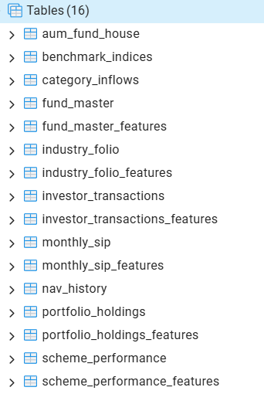
6.1 Dataset Tables
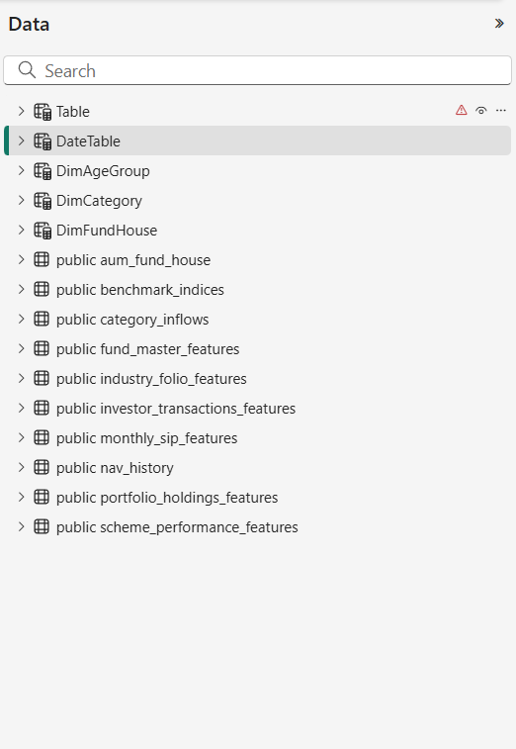
Figure 6.1: PostgreSQL Database Tables Used in the Project
Imported Data From SQL to PowerBI

7. Technical Implementation
The successful development of the Mutual Fund Analytics Dashboard required a structured data analytics workflow consisting of data collection, preprocessing, database management, transformation, modeling, and visualization. Multiple tools were used at different stages of the project to ensure data quality, efficient storage, and meaningful business insights.
The implementation process followed the sequence below:
Raw Datasets → Python (Data Cleaning) → PostgreSQL Database → Power BI (Power Query) → Data Modeling → DAX Measures → Interactive Dashboards
This workflow ensured that the data remained accurate, consistent, and optimized for reporting.

7.1 Data Cleaning and Preprocessing using Python
The raw datasets contained data from multiple sources related to mutual fund schemes, investor transactions, category inflows, SIP trends, NAV history, and fund houses. Before importing the data into Power BI, the datasets were cleaned using Python in Jupyter Notebook.
The Python libraries Pandas and NumPy were used to preprocess the data and improve its quality.
The following data cleaning activities were performed:
- Imported multiple CSV datasets into Jupyter Notebook.
- Checked dataset dimensions and data types.
- Identified and handled missing values.
- Removed duplicate records.
- Standardized column names for consistency.
- Converted columns to appropriate data types.
- Corrected formatting inconsistencies.
- Removed unnecessary columns where required.
- Exported the cleaned datasets for database storage.
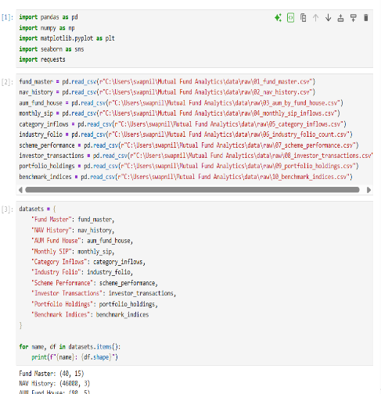
These preprocessing steps improved the reliability of the data and ensured accurate analysis during dashboard development.
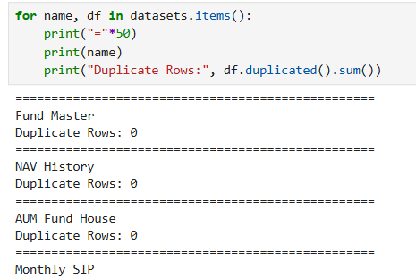
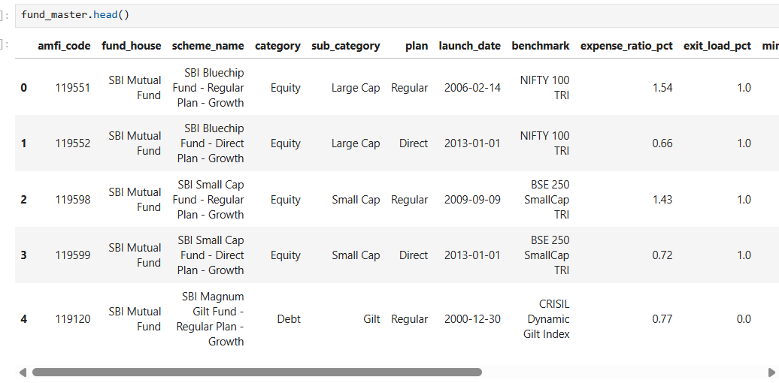

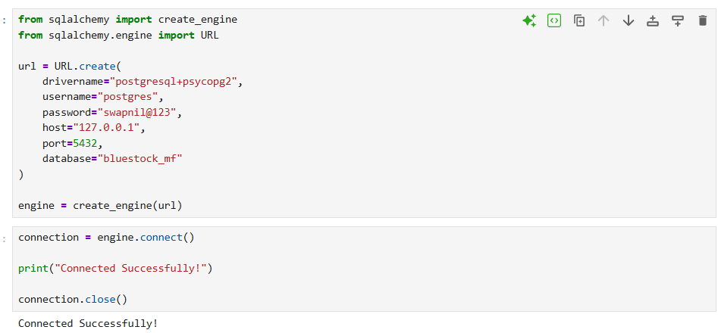
Figure 7.1: Python Data Cleaning in Jupyter Notebook

7.2 Database Management using PostgreSQL
After cleaning the datasets in Python, the processed data was imported into a PostgreSQL database. PostgreSQL served as the centralized repository for storing structured mutual fund data.
Using a relational database provided better organization of the datasets and enabled efficient connectivity with Microsoft Power BI.
The following activities were performed:
- Created a PostgreSQL database.
- Imported cleaned datasets into relational tables.
- Verified successful data import.
- Maintained consistent table structures.
- Used PostgreSQL as the primary data source for Power BI.
This approach improved data management and demonstrated the use of SQL databases in a Business Intelligence workflow.
Figure 7.2: PostgreSQL Database Tables


7.3 Data Transformation using Power Query
After connecting Microsoft Power BI to the PostgreSQL database, the imported datasets underwent additional transformation using Power Query. This step ensured that the data was properly formatted, standardized, and optimized for analysis before being loaded into the data model.
Power Query served as the ETL (Extract, Transform, Load) tool within Power BI, enabling efficient data preparation without altering the original source data.
The following transformations were performed:
- Imported tables directly from the PostgreSQL database.
- Verified and corrected data types.
- Renamed columns for consistency and readability.
- Removed unnecessary columns.
- Applied Trim and Clean operations where required.
- Created custom columns for analytical purposes.
- Ensured consistency across related tables.
- Loaded the transformed datasets into the Power BI data model.
These transformations improved data quality and ensured accurate relationships and calculations throughout the dashboard.
7.4 Data Modeling
A well-structured data model was designed to establish relationships between multiple datasets and enable efficient filtering and aggregation across the dashboards. The data model follows a relational approach by connecting fact tables with dimension tables, ensuring consistent reporting and improved performance.
Dimension tables such as DimCategory and DimFundHouse were created to simplify filtering and maintain consistency across multiple fact tables.
The following relationships were established:
- Fund House ↔ AUM Data
- Fund House ↔ Scheme Performance
- Category ↔ Category Inflows
- Category ↔ Scheme Performance
- Investor Transactions ↔ Date and Demographic Data (where applicable)
The model was designed with active one-to-many relationships wherever possible to support efficient filtering and reduce ambiguity.
A properly designed data model improves report performance, ensures accurate calculations, and enables interactive cross-filtering between visuals.

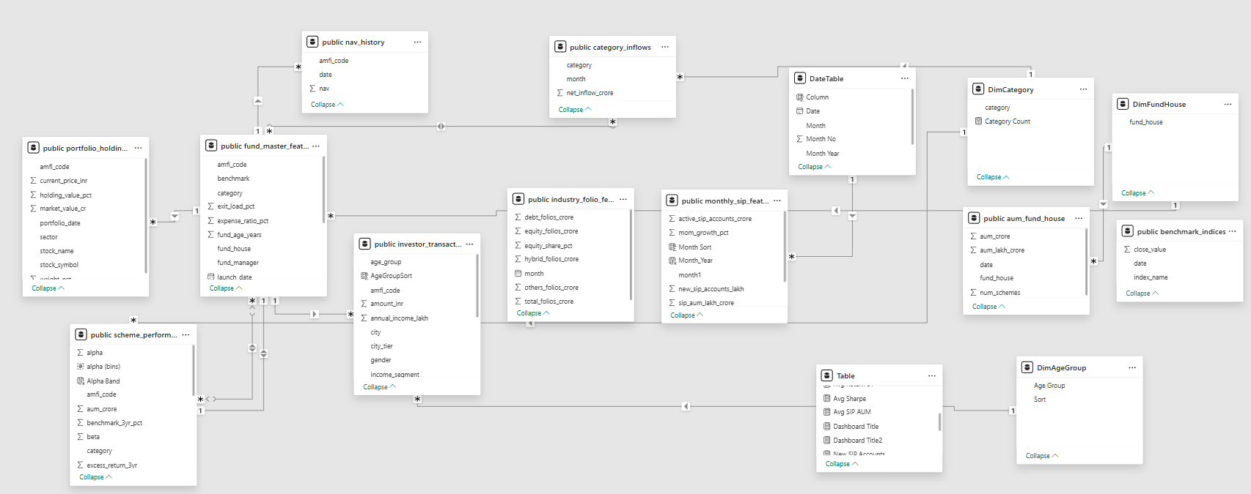
Figure 7.4: Power BI Data Model (Relationships View)

7.5 DAX Measures and KPIs
Data Analysis Expressions (DAX) were used extensively to create calculated measures and Key Performance Indicators (KPIs) that support dynamic reporting and business analysis. These measures enabled the dashboard to summarize complex financial information and respond dynamically to user selections.
Some of the key DAX measures developed in this project include:
- Total Assets Under Management (AUM)
- Total Mutual Fund Schemes
- Average 1-Year Return
- Average 3-Year Return
- Average Alpha
- Average Sharpe Ratio
- Total Investment Amount
- Total Investors
- Average Investment per Investor
- Total SIP Inflow
- Active SIP Accounts
- Monthly SIP Growth
- Dynamic Dashboard Titles
These measures were used to populate KPI cards, charts, and interactive visuals across all four dashboard pages. Dynamic DAX calculations also enabled slicer-based filtering and contextual titles, improving the overall user experience.
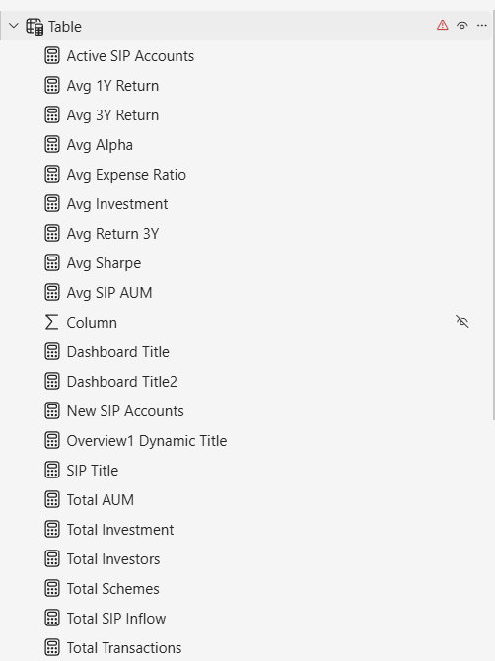
Figure 7.5: Sample DAX Measures Used in the Project
8. Dashboard Design and Analysis
The Mutual Fund Analytics Dashboard was developed using Microsoft Power BI to provide stakeholders with an interactive platform for analyzing mutual fund performance, investor behavior, and SIP market trends. The solution consists of four interconnected dashboards designed to present business insights through KPIs, charts, slicers, and dynamic visualizations.
Each dashboard focuses on a specific analytical objective while maintaining a consistent design theme, intuitive navigation, and interactive filtering capabilities.

8.1 Overview Dashboard
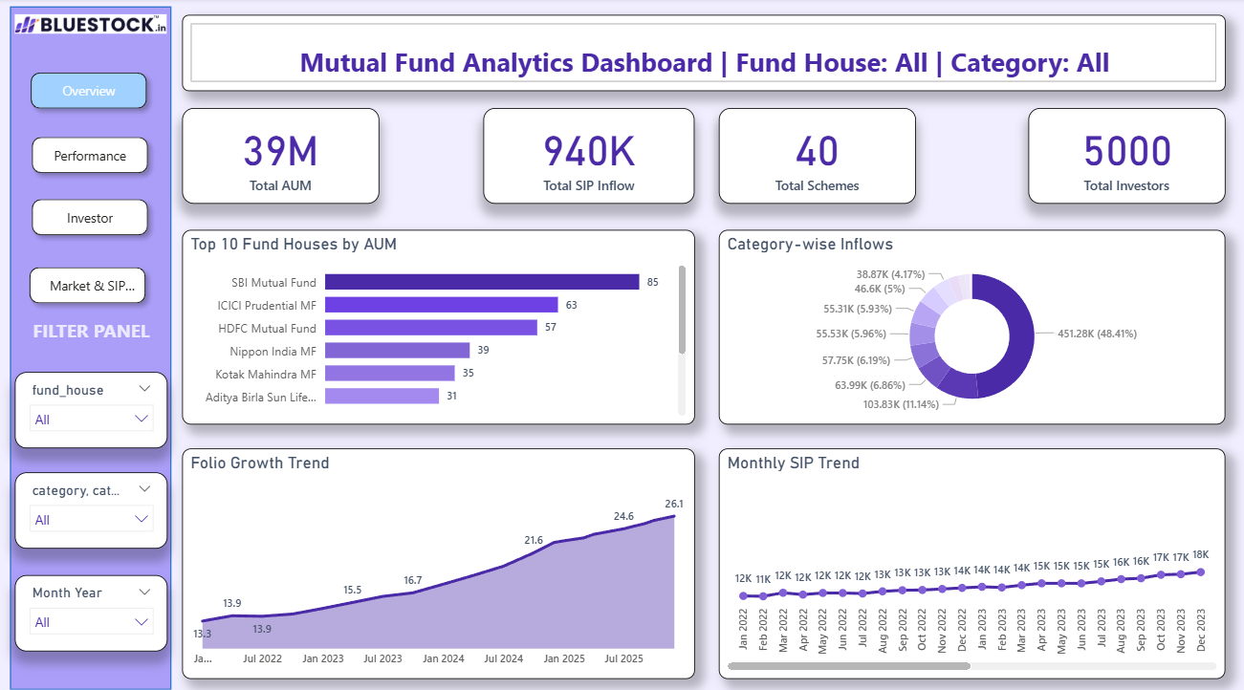
Figure 8.1: Overview Dashboard
Purpose
The Overview Dashboard provides a high-level summary of the mutual fund ecosystem by presenting key financial metrics and category-level insights. It acts as the landing page of the report, allowing users to quickly assess overall market performance before exploring detailed analyses.
Key Performance Indicators (KPIs)
The dashboard includes the following KPIs:
- Total Assets Under Management (AUM)
- Total Mutual Fund Schemes
- Total Fund Houses
- Average Return
- Average Alpha
- Average Sharpe Ratio
Visualizations
The dashboard includes several interactive visuals to summarize the data effectively:
- Top Fund Houses by Assets Under Management (AUM)
- Category-wise Inflows
- Monthly Folio Growth Trend
- Interactive slicers for Fund House and Category
- Dynamic dashboard title based on user selections
Business Value
The Overview Dashboard enables users to:
- Monitor the overall health of the mutual fund market.
- Compare fund houses based on assets under management.
- Analyze category-wise investment inflows.
- Identify overall market growth trends.
- Navigate efficiently to detailed analytical dashboards.
This dashboard serves as the primary entry point for business users and provides a concise summary of key financial indicators.
8.2 Fund Performance Dashboard
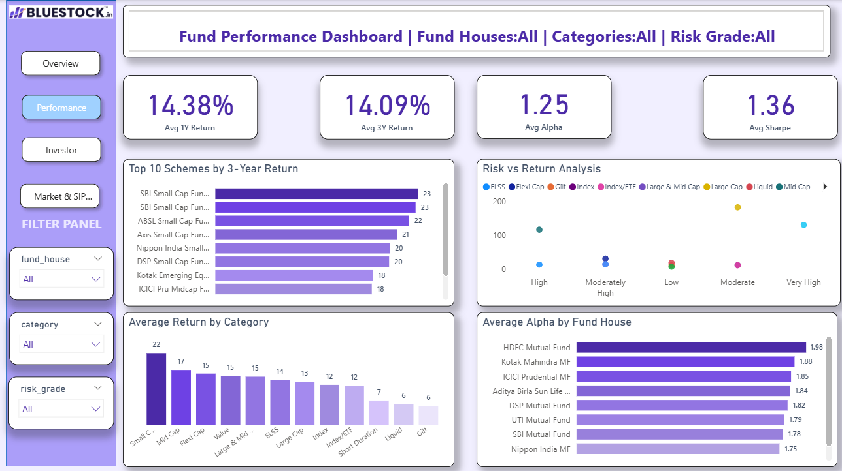
Figure 8.2: Fund Performance Dashboard
Purpose
The Fund Performance Dashboard provides a detailed analysis of mutual fund schemes by evaluating their returns, risk metrics, and overall performance. It enables users to compare different fund houses and investment categories using key financial indicators.
Key Performance Indicators (KPIs)
The dashboard includes the following KPIs:
- Average 1-Year Return
- Average 3-Year Return
- Average Alpha
- Average Sharpe Ratio
- Total Schemes
Visualizations
The dashboard contains the following interactive visuals:
- Top Performing Mutual Fund Schemes
- Average Returns by Category
- Alpha Analysis by Fund House
- Sharpe Ratio Comparison
- Risk Grade Distribution
- Fund House and Category Slicers
- Dynamic Dashboard Title
Business Value
The Fund Performance Dashboard helps investors and financial analysts to:
- Compare the performance of different mutual fund schemes.
- Evaluate risk-adjusted returns using Alpha and Sharpe Ratio.
- Identify top-performing fund houses.
- Analyze investment categories based on historical returns.
- Make informed investment decisions using quantitative performance metrics.
The dashboard simplifies the evaluation of mutual fund performance through interactive visualizations and financial KPIs.

8.3 Investor Analytics Dashboard
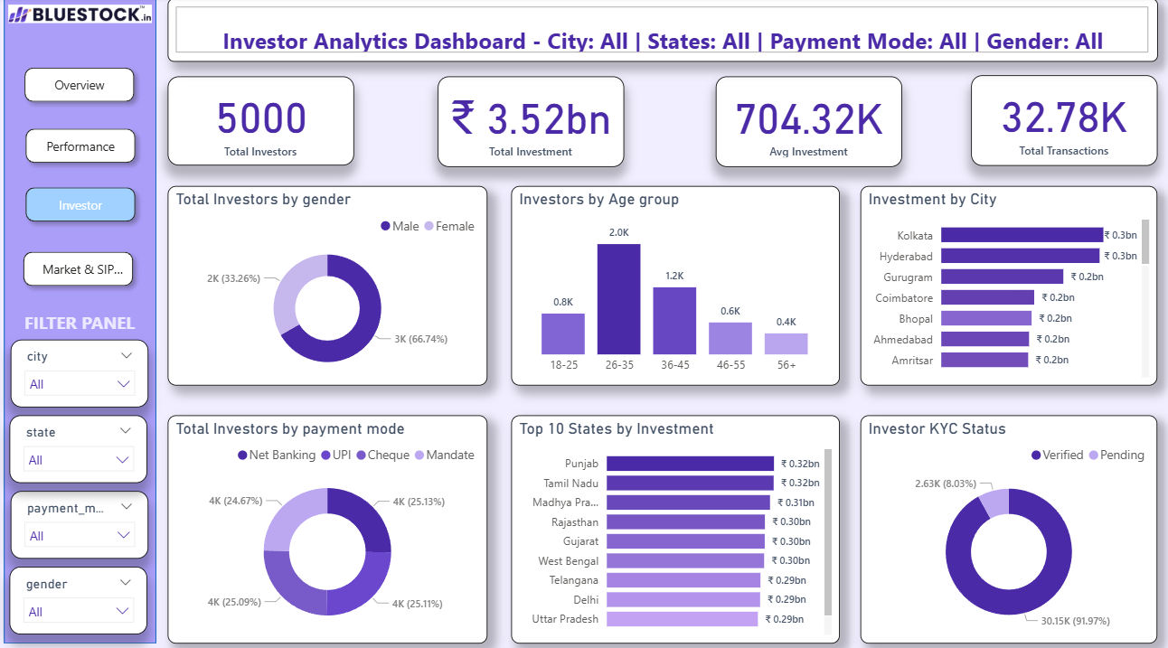
Figure 8.3: Investor Analytics Dashboard
Purpose
The Investor Analytics Dashboard focuses on understanding investor demographics, investment behavior, and transaction patterns. It provides valuable insights into how different groups of investors participate in mutual fund investments.
Key Performance Indicators (KPIs)
The dashboard includes:
- Total Investors
- Total Investment Amount
- Average Investment
- Total Transactions
Visualizations
The dashboard includes:
- Investment by City
- Investment by State
- Gender Distribution
- Age Group Distribution
- Payment Mode Analysis
- KYC Status Distribution
- Occupation-wise Investment Analysis
- Dynamic Dashboard Title
- Interactive Slicers
Business Value
The Investor Analytics Dashboard enables financial institutions to:
- Understand investor demographics.
- Analyze geographical investment distribution.
- Identify high-value investor segments.
- Study payment preferences.
- Monitor KYC compliance.
- Improve customer segmentation and targeted financial services.
The dashboard provides actionable insights into investor behavior, enabling organizations to make customer-focused business decisions.
8.4 Market & SIP Trends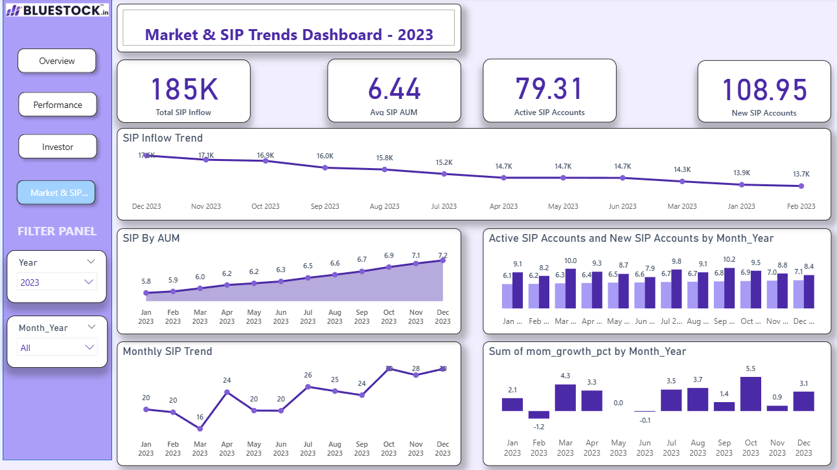

Figure 8.4: Market & SIP Trends Dashboard
Purpose
The Market & SIP Trends Dashboard provides insights into the growth of Systematic Investment Plans (SIPs) and overall market trends. It enables users to monitor investment activity over time and evaluate the performance of SIP-related metrics.
Key Performance Indicators (KPIs)
The dashboard includes:
- Total SIP Inflow
- Active SIP Accounts
- New SIP Registrations
- Average Monthly SIP Contribution
Visualizations
The dashboard contains:
- Monthly SIP Inflow Trend
- Active SIP Growth
- New SIP Registrations
- Category-wise SIP Analysis
- Fund House Comparison
- Trend Analysis using Line Charts
- Interactive Slicers
- Dynamic Dashboard Title
Business Value
The Market & SIP Trends Dashboard assists stakeholders in:
- Monitoring the growth of SIP investments.
- Identifying seasonal investment trends.
- Evaluating investor participation over time.
- Comparing SIP performance across fund categories.
- Supporting strategic planning for mutual fund companies.
The dashboard presents historical SIP trends in an intuitive and interactive format, helping organizations evaluate market performance and investor engagement.

9. Business Insights and Findings
The interactive dashboards developed in this project provide meaningful insights into mutual fund performance, investor behavior, and SIP market trends. The following observations were derived from the analysis:
Key Business Insights
- The dashboard provides a consolidated view of mutual fund performance by integrating multiple datasets into a single analytical platform.
- Assets Under Management (AUM) vary significantly across fund houses, indicating differences in market share and investor confidence.
- Category-wise inflow analysis highlights which mutual fund categories attract the highest investor interest.
- Risk-adjusted performance metrics such as Alpha and Sharpe Ratio help identify schemes that have delivered superior returns relative to risk.
- Historical return analysis enables investors to compare the performance of different schemes over multiple investment periods.
- Investor demographic analysis shows how investment behavior varies across age groups, genders, occupations, and locations.
- City-wise and state-wise investment analysis identifies regions with higher mutual fund participation.
- Payment mode analysis reveals investor preferences for different transaction methods.
- KYC status analysis provides insights into investor compliance and onboarding.
- Monthly SIP trend analysis helps track investment growth and investor participation over time.
- Interactive slicers and dynamic titles enable users to perform customized analysis without modifying the underlying data.
- The dashboard supports faster and more informed decision-making by presenting complex financial information through intuitive visualizations.
Overall Findings
The developed dashboard successfully transforms raw financial data into meaningful business insights. By combining data preprocessing, database management, data modeling, and interactive reporting, the solution enables stakeholders to evaluate fund performance, understand investor behavior, and monitor market trends efficiently. The dashboard serves as a practical decision-support system for financial analysis and demonstrates the effective application of Business Intelligence techniques in the mutual fund domain.

10. Recommendations
Based on the analysis performed in this project, the following recommendations are suggested:
- Focus on high-performing mutual fund categories while maintaining an appropriate level of portfolio diversification.
- Monitor risk-adjusted performance metrics such as Alpha and Sharpe Ratio in addition to absolute returns when evaluating schemes.
- Encourage greater SIP adoption through awareness programs and investor education initiatives.
- Use demographic insights to design personalized investment products and targeted marketing campaigns.
- Improve investor engagement in regions with comparatively lower participation through localized outreach strategies.
- Continue monitoring category-wise inflows to identify emerging investment trends and changing investor preferences.
- Integrate real-time market data in future versions of the dashboard to enable live performance monitoring.
- Leverage dashboard insights to support strategic planning, investment advisory services, and business decision-making.

11. Challenges Faced
During the development of the Mutual Fund Analytics Dashboard, several technical and analytical challenges were encountered. These challenges provided valuable learning opportunities and enhanced practical problem-solving skills.
Major Challenges
1. Data Cleaning
The raw datasets contained inconsistencies in data types, formatting, and column structures. Python (Jupyter Notebook) was used to clean, standardize, and prepare the datasets for further analysis.
2. Database Integration
Importing multiple cleaned datasets into PostgreSQL and ensuring proper table structures required careful planning. Maintaining consistency across related tables was essential for successful integration with Power BI.
3. Data Modeling
Designing relationships between multiple fact and dimension tables was one of the most challenging tasks. Creating dimension tables such as DimCategory and DimFundHouse helped establish efficient one-to-many relationships and improve filtering performance.
4. DAX Calculations
Developing dynamic measures, KPIs, and dashboard titles required a strong understanding of DAX functions and filter context. Several calculations were refined to ensure accurate results under different slicer selections.
5. Dashboard Design
Maintaining a consistent theme, selecting appropriate visualizations, arranging dashboard layouts, and ensuring readability required multiple design iterations to achieve a professional appearance.
6. Interactive Features
Implementing page navigation, slicers, bookmarks, dynamic titles, and cross-filtering while maintaining report performance required careful configuration and testing.
Learning Outcomes
Overcoming these challenges strengthened practical knowledge of Python, PostgreSQL, Power BI, Power Query, DAX, and data modeling. The project also improved skills in dashboard design, business analysis, and data-driven storytelling.

12. Conclusion
The Mutual Fund Analytics Dashboard successfully demonstrates the application of Business Intelligence techniques to analyze complex financial data and transform it into meaningful business insights.
The project followed a complete end-to-end analytics workflow, beginning with data cleaning in Python, database management using PostgreSQL, data transformation through Power Query, data modeling and DAX development in Power BI, and finally the creation of interactive dashboards for reporting and analysis.
The four dashboards provide a comprehensive view of mutual fund performance, investor demographics, and SIP market trends through interactive visualizations, KPIs, and dynamic filtering capabilities. These dashboards enable stakeholders to evaluate investment performance, compare fund houses, analyze investor behavior, and monitor market trends effectively.
This project not only strengthened technical skills in Python, SQL, Power BI, Power Query, and DAX but also enhanced the ability to design user-friendly dashboards and communicate insights through data visualization. The completed solution demonstrates the practical application of Business Intelligence in the financial domain and supports informed, data-driven decision-making.
13. Future Scope
Although the current dashboard provides comprehensive analytical capabilities, several enhancements can further improve its functionality and business value.
Future Enhancements
- Integrate real-time mutual fund data using APIs.
- Develop predictive models to forecast fund performance using machine learning.
- Add AI-powered insights and anomaly detection for investment analysis.
- Implement row-level security (RLS) to provide secure, role-based access to reports.
- Publish the dashboard to the Power BI Service for cloud-based access and collaboration.
- Develop a mobile-optimized version of the dashboard for on-the-go analysis.
- Expand the dashboard by incorporating benchmark indices, macroeconomic indicators, and global market trends.
- Automate data refresh using scheduled PostgreSQL updates and Power BI refresh capabilities.
These enhancements would improve scalability, usability, and decision-support capabilities, making the solution suitable for enterprise-level financial reporting.
14. References
- Microsoft Power BI Documentation
- Microsoft Learn – Power BI Learning Paths
- PostgreSQL Official Documentation
- Python Documentation
- Pandas Documentation
- NumPy Documentation
- Bluestock Capstone Project Dataset
- Microsoft Power Query Documentation
- DAX Guide (SQLBI)

